**“HOSTEL ACCOMMODATION SYSTEM”**

A Mini Project

Submitted by

Shreyas Chavhan (SC055)

Sonal Shitole (SC056)

Saurabh Deshmane(SC057)

SECOND YEAR COMPUTER ENGINEERING

Under the Guidance of

Dr. Ajitkumar Shitole



Department of Computer Engineering

Hope Foundation's

International Institute of Information Technology

Hinjawadi, Pune – 411057

AY 2020-2021

Semester-1

**TABLE OF CONTENTS**

(Page Number)

1. PROBLEM STATEMENT 3

2. INTRODUCTION 3

3. ALGORITHM AND FLOWCHART

4. REQUIREMENTS 4

4.1 SOFTWARE AND HARDWARE DETAILS 6

4.2 LIBRARIES / PACKAGES USED 6

5. RESULT 7

6. CONCLUSION 10

7. REFERENCES 10

**1 PROBLEM STATEMENT**

**Write a program in Python/C/C++ to implement Hostel Accommodation System which should**

**consist of following operations: 1. Insert 2. Display 3. Search 4. Modify**

**2 INTRODUCTION**

This system is designed in favor of the hostel management which helps them to save the records of the students about their rooms. It helps them from the manual work from which it is very difficult to find the record of the students and the information of those ones who had left the hostel three years before. The students of the hostel will be recognized from the name given and allocated room and floor number at the room rental time.

**3 ALGORITHM AND FLOWCHART**

**Algorithm -**

**Create Function -**

1. Start

2. iterate over number of floors

3. write a nested loop into the floor loop for rooms

4. create a new node in dynamic memory

6. initialize next and previous pointer of new node as null

7. check if head nodes is null, if so point head node to the newnode,

8. else, point created node pointer to the head node.

9. check until the next pointer is not equal to null, if so, move point the created node to the next node.

10. create room capacity according to room number.

11. link next and previous pointer of created node and newnode to each other respectively.

**Book function -**

1. Start

2. input floor number and room number and if data invalid output error otherwise move ahead

3. check if room capacity is sufficient for the number of peoples we want to book room for.

4. if that satisfies, ask for their name and fill the room, else display room currently not available.

**Cancel Function** -

1. Start

2. input floor number and room number and if data invalid output error otherwise move ahead

3. check if the person is present in the room,

4. if present, delete the record else display an error as "record not available"

**Display function -**

1. Start

2. initialize a counter for every floor required

3. create and point a pointer of class Node to head node of every class

4. traverse through each node using that pointers and display the room capacity and if the room is available or not.

5. if room is not available, display who have booked the room

**Search function -**

1. Start

2. Traverse through each and every index of the stored name 2d array

3. check where the index is found and display the indices i.e. room number and floor number

**Flow Chart -**

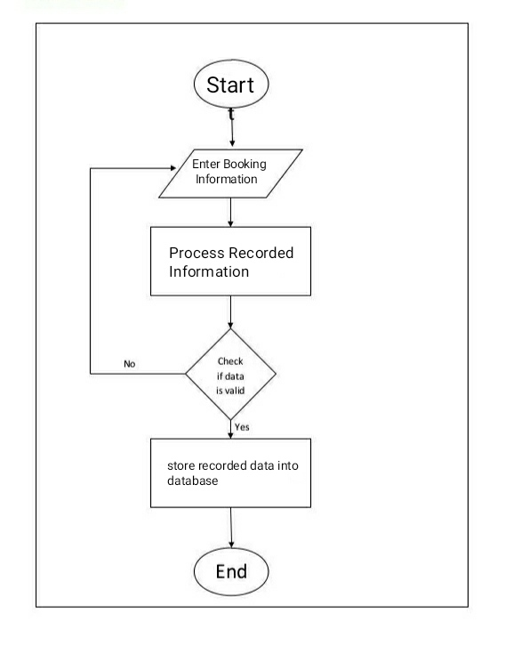

1. **REQUIREMENTS**

**4.1 SOFTWARE REQUIREMENTS**

* Operating System: Windows 7/8//10
* Language used: c++
* IDE used: VScode and atom editor
* Compiler used: mingw-w64

**LIBRARIES/PACKAGES USED**

We have used standard c++ libraries such as

**#include <bits/stdc++.h>**  This file **includes** all standard library.

1. **RESULT**

**Choices and room allocation**

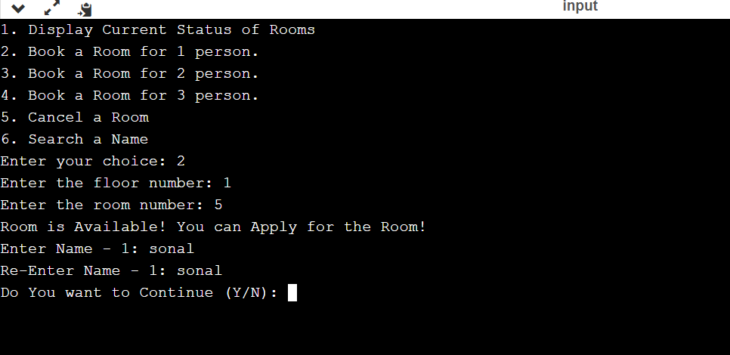

Display allotment status

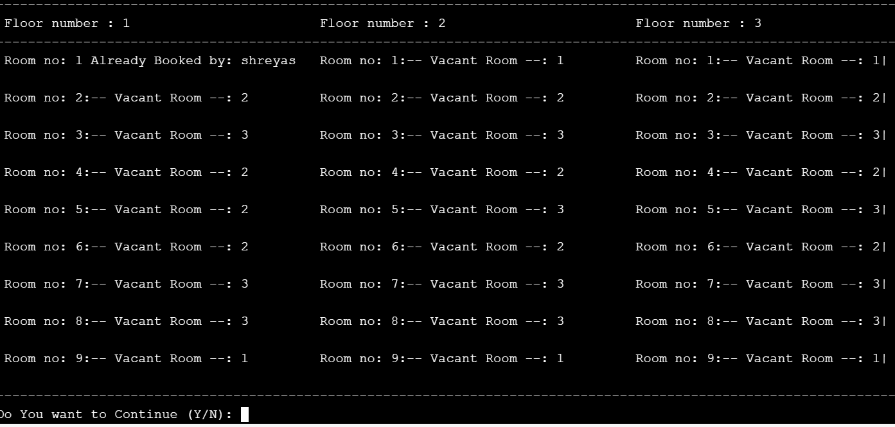

**Searching student’s details of room and floor**

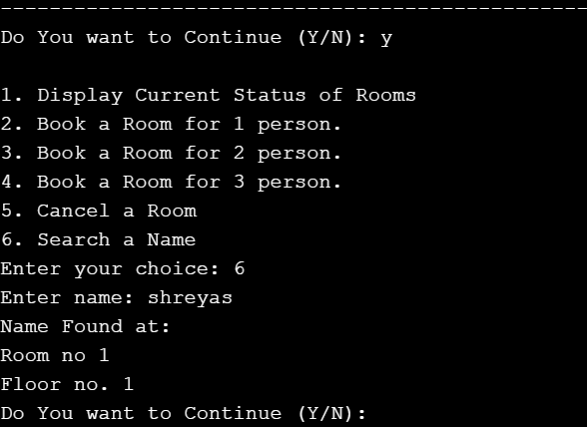

**6 CONCLUSION**

Hostel Management System is a Customize and user-friendly software for Hostel. It has been designed to automate, manage and look after the overall processing of even very large hostel. It is capable of managing Enquiry details, Student Details, Payment Details etc. Hostel Management System is a Customize and user-friendly software for Hostel which provide hostel information, hostel room information, hostel accounts information.

**7 REFERENCES**

https://en.cppreference.com/w/